Use Case Testing

Definition
# Source: AI Source: Provided by: [Data Path: Persons Table -> ID Column: 1, Name_En Column: Motasem Essam] -> From: [ChatGPT] on [8/24/2025]
Use Case Testing is a black-box test design technique that creates test cases based on use cases — descriptions of how users (actors) interact with the system to achieve a goal.
It focuses on real-world usage scenarios to ensure the system works as expected from the user’s perspective.

Key Ideas
# Source: AI Source: Provided by: [Data Path: Persons Table -> ID Column: 1, Name_En Column: Motasem Essam] -> From: [ChatGPT] on [8/24/2025]
- Actor → A user or another system interacting with your system.
- Use case → A documented scenario describing a sequence of steps between an actor and the system to achieve an outcome.
- Main success path → The ideal, expected sequence of events.
- Alternative paths → Other valid ways to complete the scenario.
- Exception paths → Paths where something goes wrong (errors, failures).

Example
# Source: AI Source: Provided by: [Data Path: Persons Table -> ID Column: 1, Name_En Column: Motasem Essam] -> From: [ChatGPT] on [8/24/2025]
Imagine you’re testing an Online Banking – Transfer Funds feature.
Use Case: Transfer Funds
Actors: Customer (primary), Banking system (secondary)
Main success flow:
- Customer logs in.
- Selects "Transfer Funds".
- Enters recipient details and amount.
- Confirms transfer.
- System transfers funds and displays success message.
Alternative path:
- Step 3 → Customer chooses from saved recipients instead of entering details.
Exception paths:
- Step 1 → Wrong password entered 3 times → Account locked.
- Step 3 → Amount exceeds balance → Error message shown.

Testing with Use Case Technique
# Source: AI Source: Provided by: [Data Path: Persons Table -> ID Column: 1, Name_En Column: Motasem Essam] -> From: [ChatGPT] on [8/24/2025]
You create test cases for:
- Main flow (happy path)
- All alternative flows
- All exception flows
Example Test Cases:
- Successful transfer between accounts.
- Transfer using a saved recipient.
- Transfer with insufficient balance.
- Login fails after 3 wrong attempts.

Benefits
# Source: AI Source: Provided by: [Data Path: Persons Table -> ID Column: 1, Name_En Column: Motasem Essam] -> From: [ChatGPT] on [8/24/2025]
✅ Ensures coverage of end-to-end business scenarios.
✅ Focuses on user goals, not just functions.
✅ Helps validate workflows across multiple features.

When to use
# Source: AI Source: Provided by: [Data Path: Persons Table -> ID Column: 1, Name_En Column: Motasem Essam] -> From: [ChatGPT] on [8/24/2025]
- Acceptance testing
- Integration testing
- System testing where workflows matter

Coverage
# Source: AI Source: Provided by: [Data Path: Persons Table -> ID Column: 1, Name_En Column: Motasem Essam] -> From: [ChatGPT] on [8/24/2025]
Use Case Testing Coverage
📌 Definition
- Coverage items = use case scenarios or steps that the system must execute.
- Coverage = the proportion of all identified use case paths or scenarios that are exercised by test cases.

📊 Formula
Use Case Coverage (%)=Number of use case steps/scenarios exercisedTotal number of use case steps/scenarios×100\text{Use Case Coverage (\%)} = \frac{\text{Number of use case steps/scenarios exercised}}{\text{Total number of use case steps/scenarios}} \times 100

✅ Example
Suppose a login use case has these steps:
- Enter username
- Enter password
- Click login
- Display dashboard
- Total steps = 4
- Test case 1 executes steps 1–4 → covers all → 100% coverage
- Test case 2 executes only 1–3 → 3/4 = 75% coverage

🔹 Key Points
- Ensures that all functional flows described in use cases are tested.
- Useful for functional and system testing.
- Can also measure coverage of alternative and exception flows.

📊 Comparison of Coverage Across Test Techniques
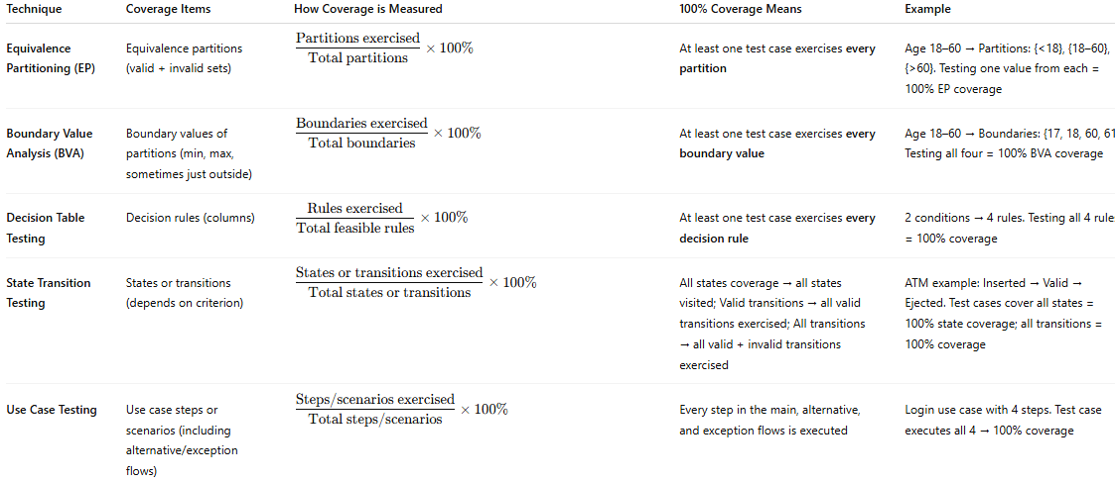
Technique | Coverage Items | How Coverage is Measured | 100% Coverage Means | Example
Equivalence Partitioning (EP) | Equivalence partitions (valid + invalid sets) | $\dfrac{\text{Partitions exercised}}{\text{Total partitions}} \times 100%$ | At least one test case exercises every partition | Age 18–60 → Partitions: {<18}, {18–60}, {>60}. Testing one value from each = 100% EP coverage
Boundary Value Analysis (BVA) | Boundary values of partitions (min, max, sometimes just outside) | $\dfrac{\text{Boundaries exercised}}{\text{Total boundaries}} \times 100%$ | At least one test case exercises every boundary value | Age 18–60 → Boundaries: {17, 18, 60, 61}. Testing all four = 100% BVA coverage
Decision Table Testing | Decision rules (columns) | $\dfrac{\text{Rules exercised}}{\text{Total feasible rules}} \times 100%$ | At least one test case exercises every decision rule | 2 conditions → 4 rules. Testing all 4 rules = 100% coverage
State Transition Testing | States or transitions (depends on criterion) | $\dfrac{\text{States or transitions exercised}}{\text{Total states or transitions}} \times 100%$ | All states coverage → all states visited; Valid transitions → all valid transitions exercised; All transitions → all valid + invalid transitions exercised | ATM example: Inserted → Valid → Ejected. Test cases cover all states = 100% state coverage; all transitions = 100% coverage
Use Case Testing | Use case steps or scenarios (including alternative/exception flows) | $\dfrac{\text{Steps/scenarios exercised}}{\text{Total steps/scenarios}} \times 100%$ | Every step in the main, alternative, and exception flows is executed | Login use case with 4 steps. Test case executes all 4 → 100% coverage
|

✅ Quick Takeaways:
- EP & BVA → focus on inputs and boundaries.
- Decision Tables → focus on logical combinations of conditions and actions.
- State Transition Testing → focus on system states and transitions.
- Use Case Testing → focus on functional scenarios and flows.

